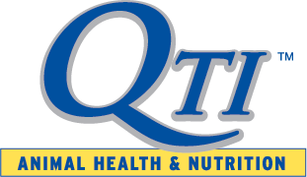
FOR IMMEDIATE RELEASE
August 28, 2019

Quality Technology International Welcomes New Turkey Sales and Marketing Manager
Elgin, IL -- Quality Technology International announces the appointment of Kolby LeJeune as Sales and Marketing Manager, focusing on the turkey market segment.
LeJeune will be providing sales and technical support for producers, veterinarians, and nutritionists. She will work with QTI’s Animal Health Team to manage existing and prospective customers.
Before joining QTI, LeJeune served as technical service manager with Agri-Way Partners LLC, and also had served with Koch Foods and Perdue Farms.
LeJeune earned a Bachelor of Science degree in Animal Science from McNeese State University.
About Quality Technology International
QTI is a leader in providing natural gut health products for conventional, organic, or ABF production. For more information, contact Quality Technology International at 847-649-9300, or by emailing info2@qtitech.com.

Contact:
Jim Bryte
jbryte@qtitech.com

